2D game construction in Swift

CS39440 Major Project Report

Author: Petter Vang Brakalsvålet ([Pev2@aber.ac.uk](mailto:Pev2@aber.ac.uk))

Supervisor: Dr/Prof. Chris Price([cjp@aber.ac.uk](mailto:cjp@aber.ac.uk))

24th March 2021

Version 0.1 (Draft)

This report is submitted as partial fulfilment of a BSc degree in  
Computer Science (With Integrated Year In Industry)

(G401)

Department of Computer Science

Aberystwyth University

Aberystwyth

Ceredigion

SY23 3DB

Wales, UK

Declaration of originality

I confirm that:

* This submission is my own work, except where clearly indicated.
* I understand that there are severe penalties for Unacceptable Academic Practice, which can lead to loss of marks or even the withholding of a degree.
* I have read the regulations on Unacceptable Academic Practice from the University’s Academic Registry (AR) and the relevant sections of the current Student Handbook of the Department of Computer Science.
* In submitting this work, I understand and agree to abide by the University’s regulations governing these issues.

Name …………………………………………

Date ……………………………………………

Consent to share this work

By including my name below, I hereby agree to this project's report and technical work being made available to other students and academic staff of the Aberystwyth Computer Science Department.

Name …………………………………………

Date ……………………………………………

Acknowledgements

I am grateful to…

I’d like to thank…

Abstract

Contents

1. Background, Analysis & Process 7

1.1. Background 7

1.2. Analysis 7

1.3. Process 8

2. Design 9

2.1. Overall Architecture 9

2.2. Detailed Design 9

2.2.1. Start screen assets 11

2.2.2. Game scene assets 12

2.2.3. User interface 14

2.3. User Interface Design 15

3. Implementation 16

4. Testing 17

4.1. Overall Approach to Testing 17

4.2. Automated Testing 17

4.2.1. Unit Tests 17

4.2.2. User Interface Testing 17

4.2.3. Stress Testing 17

4.2.4. Other Types of Testing 17

4.3. Integration Testing 17

4.4. User Testing 17

5. Critical Evaluation 18

6. Annotated Bibliography 19

7. Appendices 20

7.1. Review of similar games 21

7.1.1. Hide ‘N Seek! 21

7.1.2. Hide‘N Find 21

7.1.3. Hide & Seek Fun Game 21

7.1.4. Hide and Seek..! 21

A. Third-Party Code and Libraries 22

B. Ethics Submission 23

C. Code Samples 26

# Background, Analysis & Process

## Background

**How I started:**

When I decided that I wanted to make a 2D game with swift, I started by looking at a few different YouTube videos so that I would have an Idea of what was needed and how I was going to create the game. I started by watching a playlist called Beginning SpriteKit by raywenderlich.com to give myself an introduction.

I was also given a book by my supervisor called 2D Apple game development by tutorials. This book walked me though how to create a simple game and thought me how to move forward with creating a game.

**Research:**

To find out what the public already thought of this type of game I looked into other Hide and Seek games already on the AppStore. Here I found out that there were a few games already made and only a couple of them had good reviews, and the games that had bad reviews had very good descriptions of what people didn’t like and what they liked. I found out that all of the games where fun, addictive and that the games that allowed customizing the game did a lot better than the ones that didn’t offer this. Most of the games looked the player to one role and they had a set game duration; this seems to be the main reason why some games preformed worse.

**Motivation:**

My main motivation for creating this game was that I have some experience with iOS development, but I have never done any game development. I thought this would be a good challenge for myself and that I would get a better understanding of how games are developed and how to develop them. I was also inspired by Among us because I have played quite a bit of this during lockdown, and this gave me the idea of a map where you would be in a forest/camp site and the players would try and escape it.

## Analysis

My original task was to create a hide and seek biased game where the player would play against bots. The player would be able to choose what role they would play and how long the game would last. After I did some research, I found out that customizability of the game, and player interaction with the world is very important to create a successful game. I decided to focus on this when I was creating my game. To make my game very customizable I gave the players the option of changing settings when they start a game. (Settings include: The players role, reach movement speed, the difficulty level and how many bots the game is going to have). By doing this I ensure that the players can play a game suited for them and that I’m not forcing the players to play in a specific format. To handle player interaction, I have found that there are two main approaches to do this. I can utilise SpriteKit and use their integrated physics engine or I can set parameters for interference and use node interaction. When using Sprite Kit’s physics engine, you are using assigning physicsbodys to nodes and specifying what the node will collide whit, and as long as the nodes are in the same hight layer they will collide into each other. If I do it like this SpriteKit would handle all the collisions automatically for me and I can specify if I want something else to happen as well by changing the Physicbody delegate. However, I could also do all of this manually by checking if an node intersecting with another node and then handling the collisions and interactions. Doing it like this would be less intensive on the device running the game but it wouldn’t be as reliable as utilising SpriteKit; so, I have decided to do a combination of both. I’m utilising SpriteKit and its physics engine to handle collisions and node intersections. The physics engine will handle collisions between nodes, but I will manually handle hiding, catching or freeing of bots and players. By doing it like this I’m hoping that I will have a less intensive game, but I would keep the robustness you get from using SpriteKit and its physics.

## Process

I have tried to use an agile approach to develop this game where I have been using sprint to divide the tasks and the importance of them and I have been using stories to review them. I have split my sprints up into two weeks intervals. This have made it easier for me to set deadlines for myself, and to make sure that I’m doing enough work every sprint. At the end of every sprint, I have gone through what is in my backlog and checked what needed to be done for the next sprint.

Here is a brief overview of what has happed in the sprints. In the beginning I had a focus on learning how to develop 2D games for iOS and to build a library of game assets. I started by creating assets for the game and in sprint 1 to 2 I created most of the assets need. so, in sprint 2 to sprint 4 I worked through Chapter 1 to 3 of 2D Apple game by tutorials. This gave me a basics understanding of Game development for iOS. I looking into similar games in sprint 3 and testing the most popular games in sprint 4. This gave an idea of what to do and what not to do. I found out that most of the popular games had lots of customisability for the player, and that they give the player the option to choose which role they will have.

In sprint 3 I started to create the game. I started by creating the main menu and I set up a help page, but I didn’t add any content to the help page. After this I created a game setup page, and I added a simple game scene. During sprint 5 finished the last chapters of the getting started section of the 2D Apple games book.

A loot happened after the mid project demo and I shifted my focus to get a “functioning” game. During sprint 6 I added the players, tents, house and expanded the environment. Since I now had players in the game, I work on player interaction, and I gave the player the option to hide and to catch other players. Because of this addition I added functionality to the game setup page. The player would now be able to set their role, the number of bots and much more. One problem was that the players would always see the full screen, to fix this I added a camera and made the camera move with the player.

In sprint 7 I added bots and collision detections to the game. This made the player interaction less predictable, and I had to improve on this. After this I had a functioning game, but I didn’t have any bot movement and I decided to add automatic tests and added a victory check to the game instead of adding bot movements.

The in the last sprint I have been working on the documentation, and I have set the programming to the side. This being said I added some content to the help page. I have some tasks left in backlog. Some of the features I didn’t have time to add where pausing, trees, bot movement, and finish page.

# Design

## Overall Architecture

In this game I have use a SpriteKit architecture. I have done this because SpriteKit is Apple’s own framework developed for 2D game development and this framework can handle different actions, physics, and constraints. SpriteKit runs in a loop and by doing different steps (look at photo). 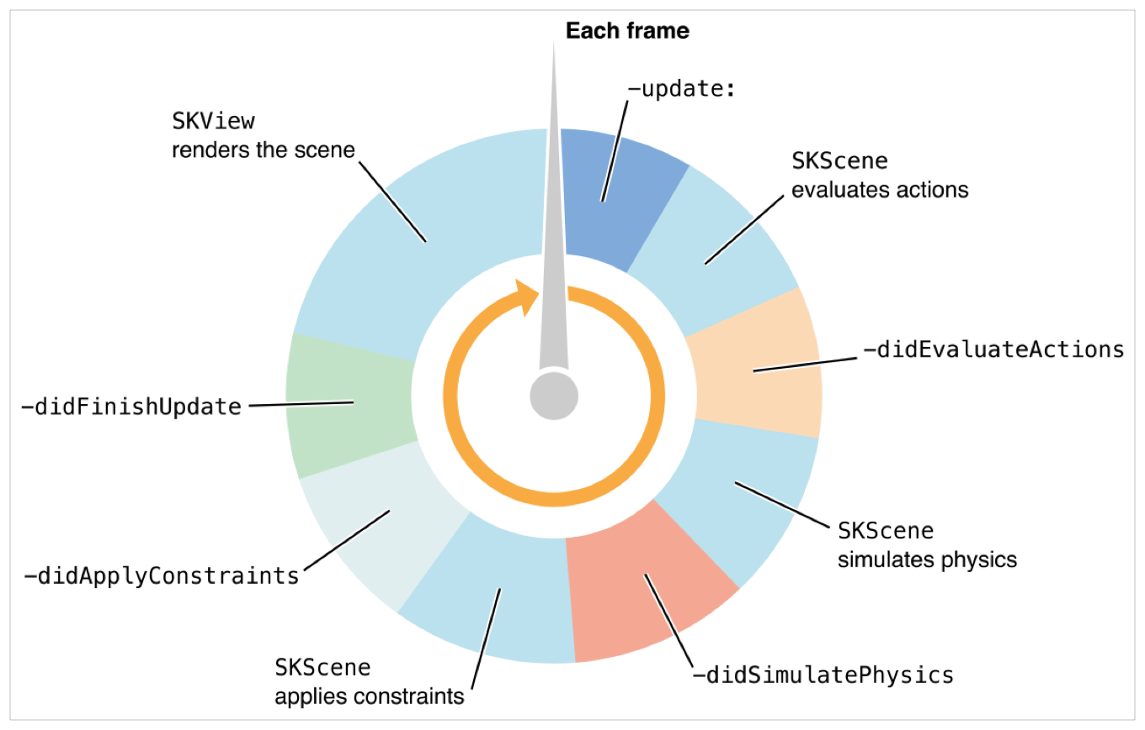

Figure 1 SpriteKit loop. See developer.apple.com [1]

I have split the functions up in to four groups and I will explain them in some details.

### Update

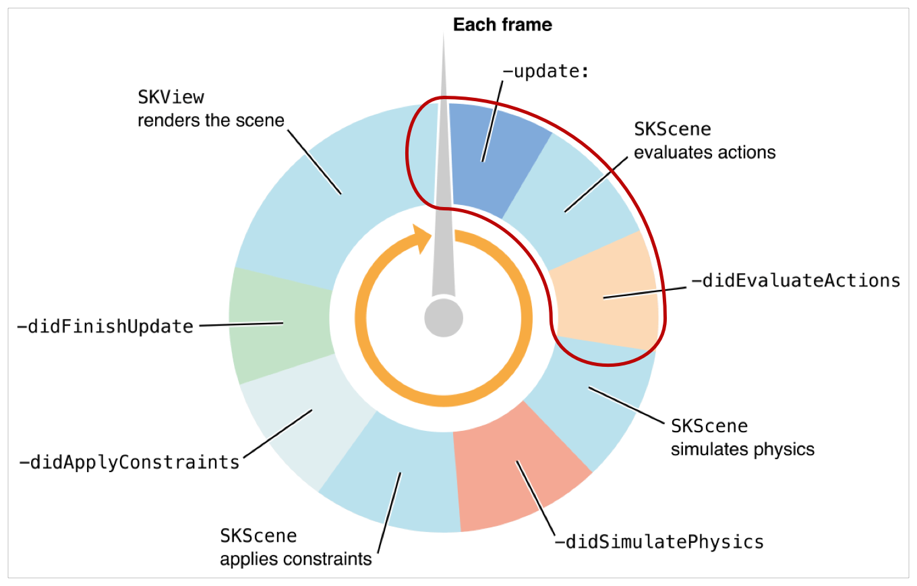

The first section of functions to be run in a frame is update the section. This section is where most of the code for the game is performed. I’m using this section for updating of movement for all nodes, and I’m using this to handle the player interactions.

### Physics

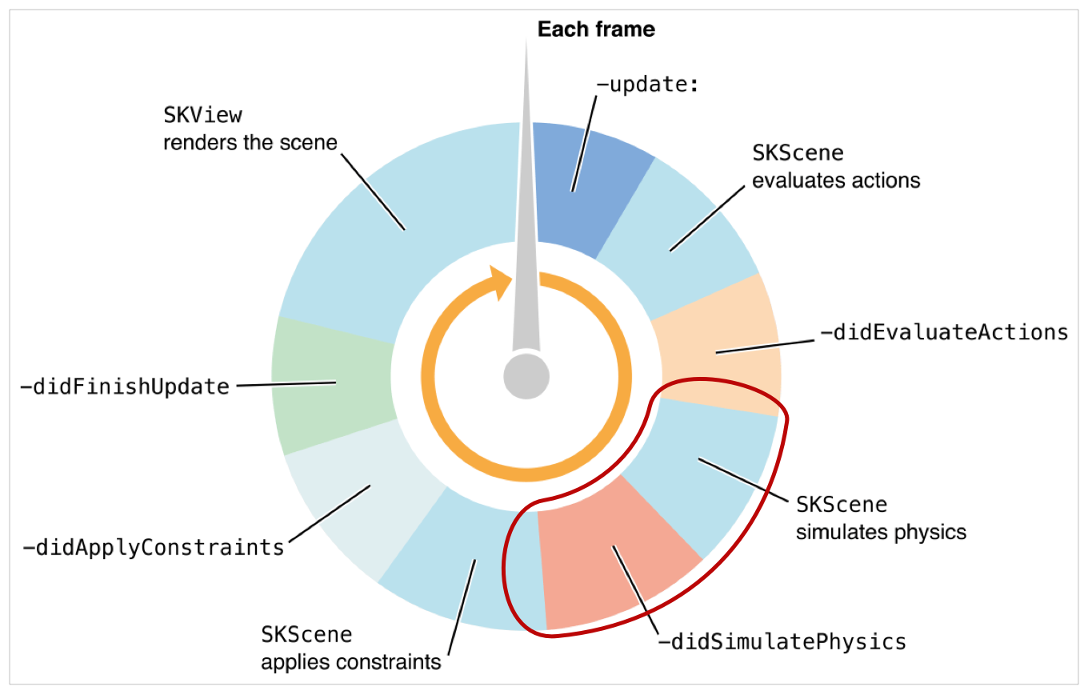

This section will handle the simulation of physics. SpriteKit can simulate some real-world physics like gravity and collisions, and this will happen in this section. I’m utilising physics simulation to handle the collisions in my game.

### Constraints

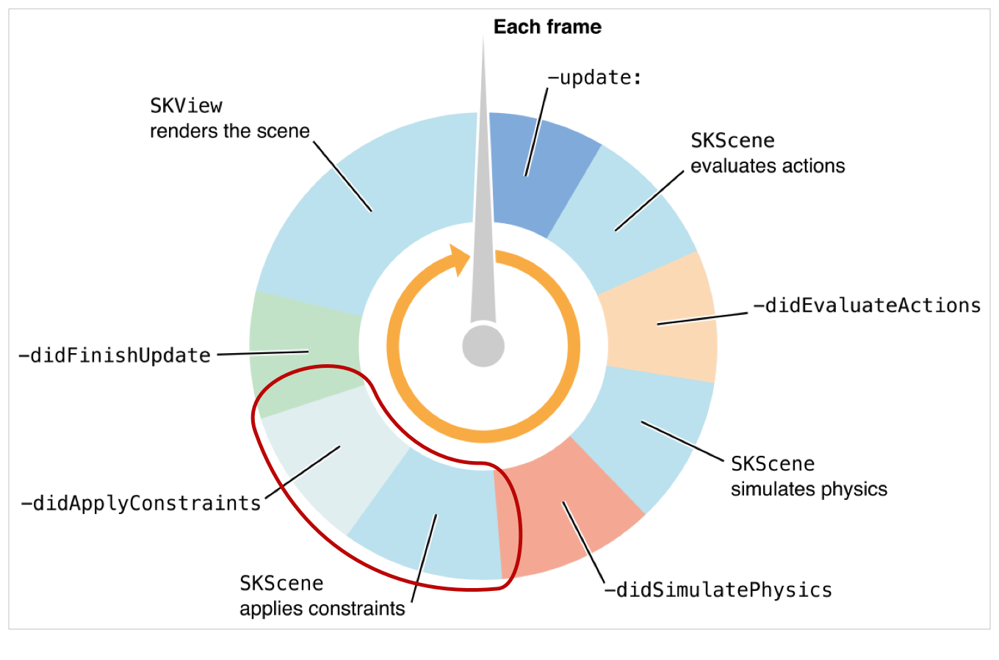

In this section constraints will be applied to the nodes of the game. I’m not using any constraints for my game and have been handling this by utilising collisions instead to get a more responsive collision. However, this section can be used to set relationships between nodes. This means that you can have multiple nodes pointing in the same directions and use constraints to make this happen.

### Rendering

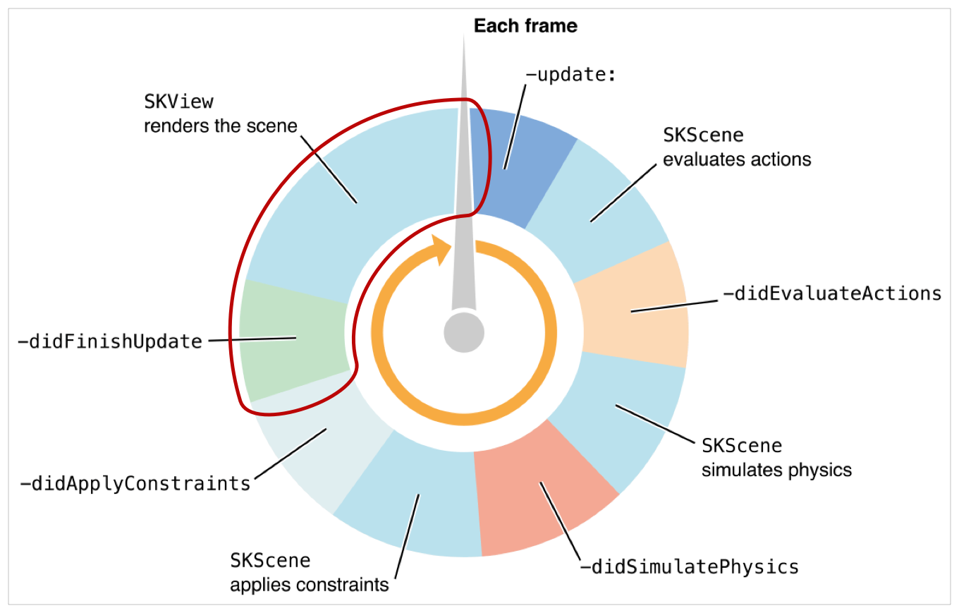

This section will handle the rendering of the game assets. This will automatically choose what resolution to be used for a node. Most game assets have three resolution variants for each asset, so that this section can use the one which is needed.

## Detailed Design

#### Main Menu

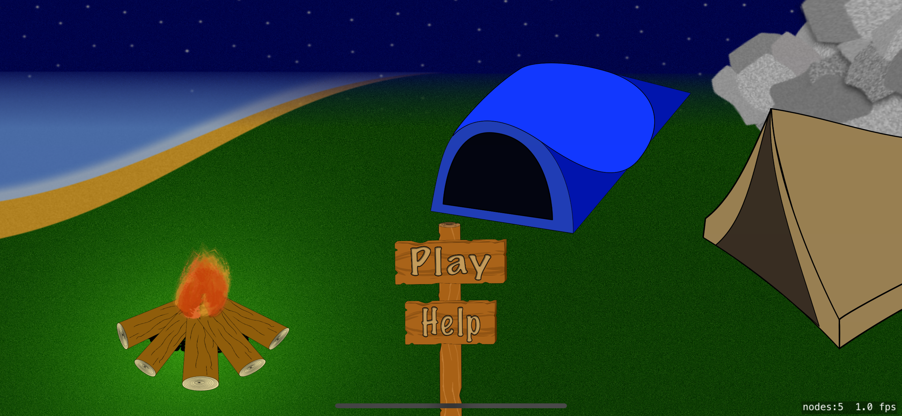

This is the main menu screen where the player can choose to play or got to the help page. This scene is supposed to show the some of the aspects of the game where you have light coming from the campfire and you have tents to hide in and the mountain in the background.

#### Help

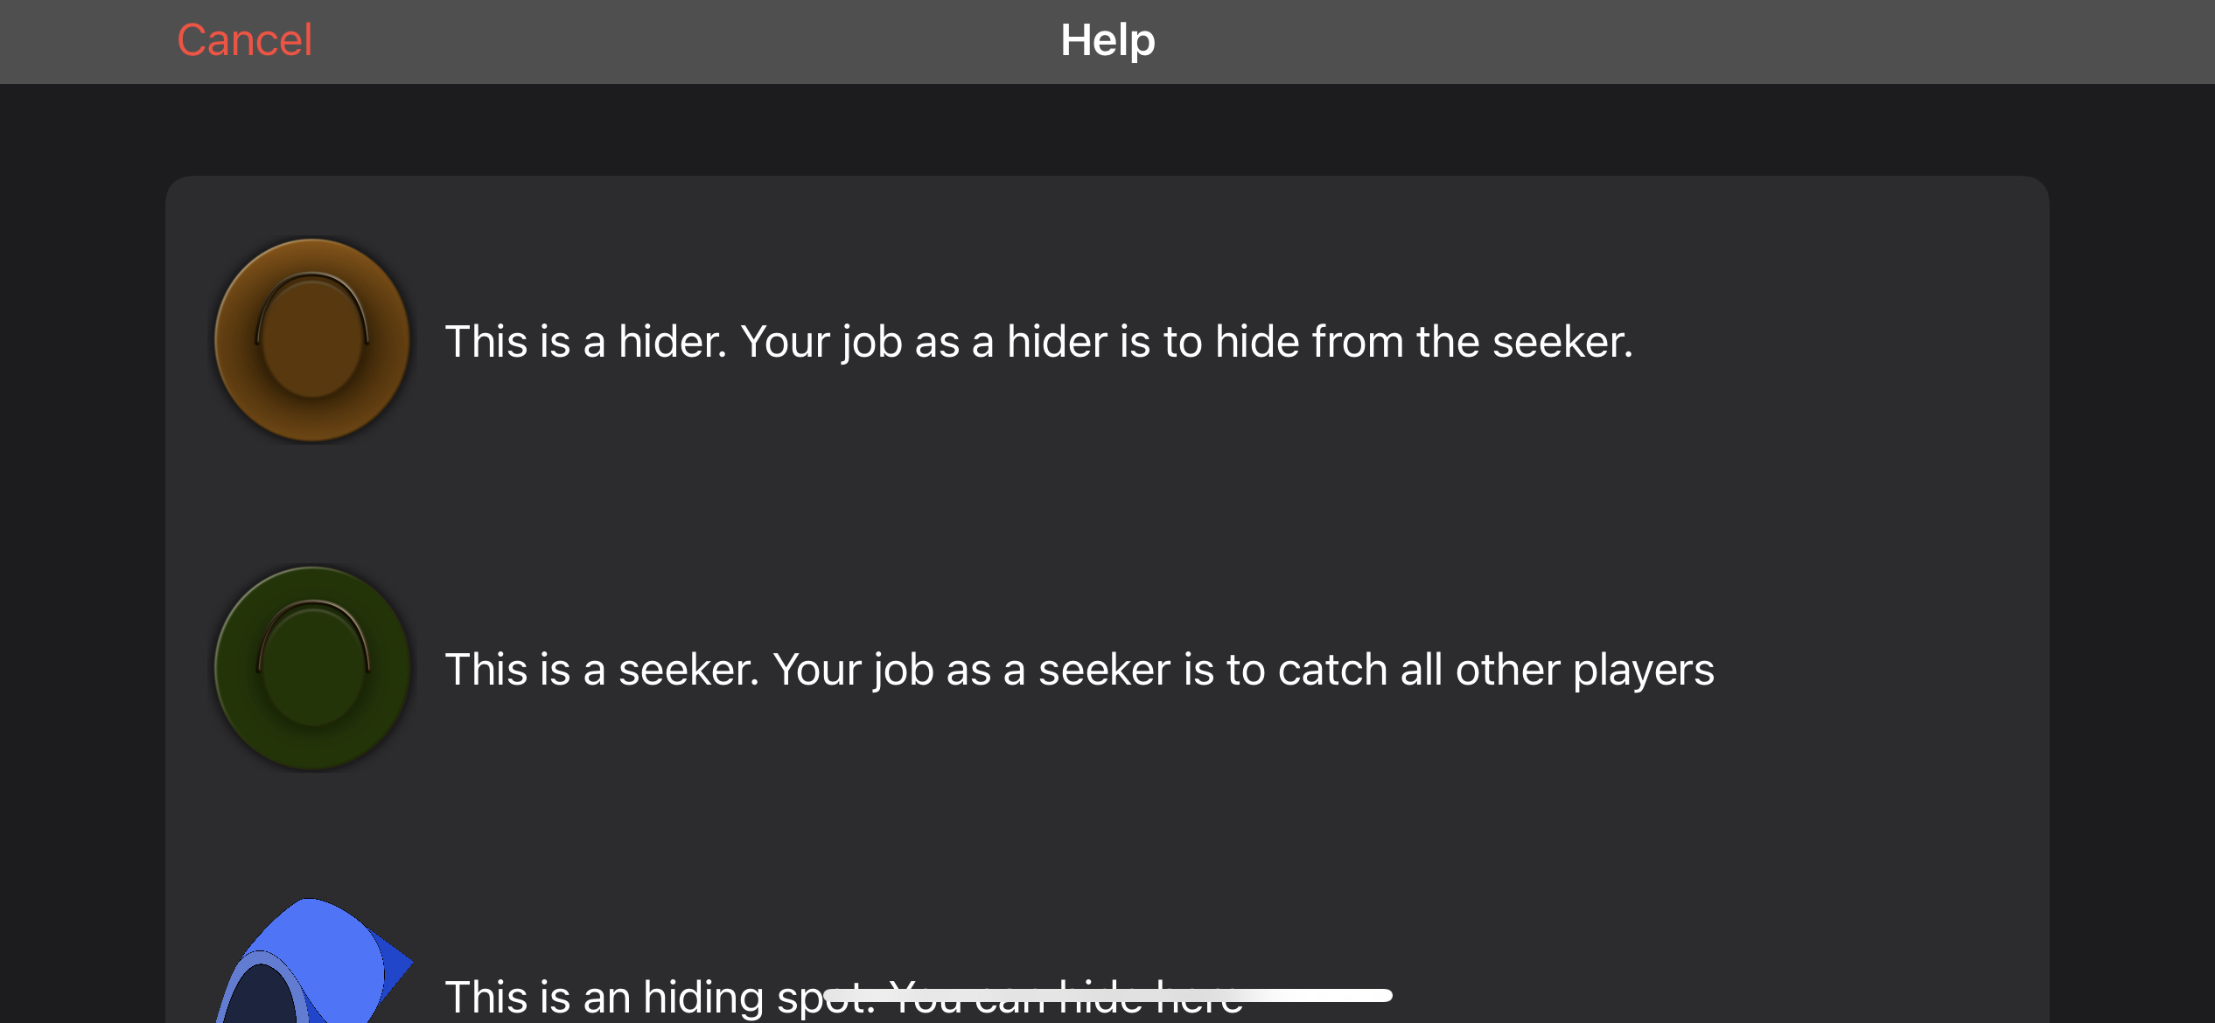

This is the help page. This page has a brief description of what some items are used for and what they are.

#### Game setup

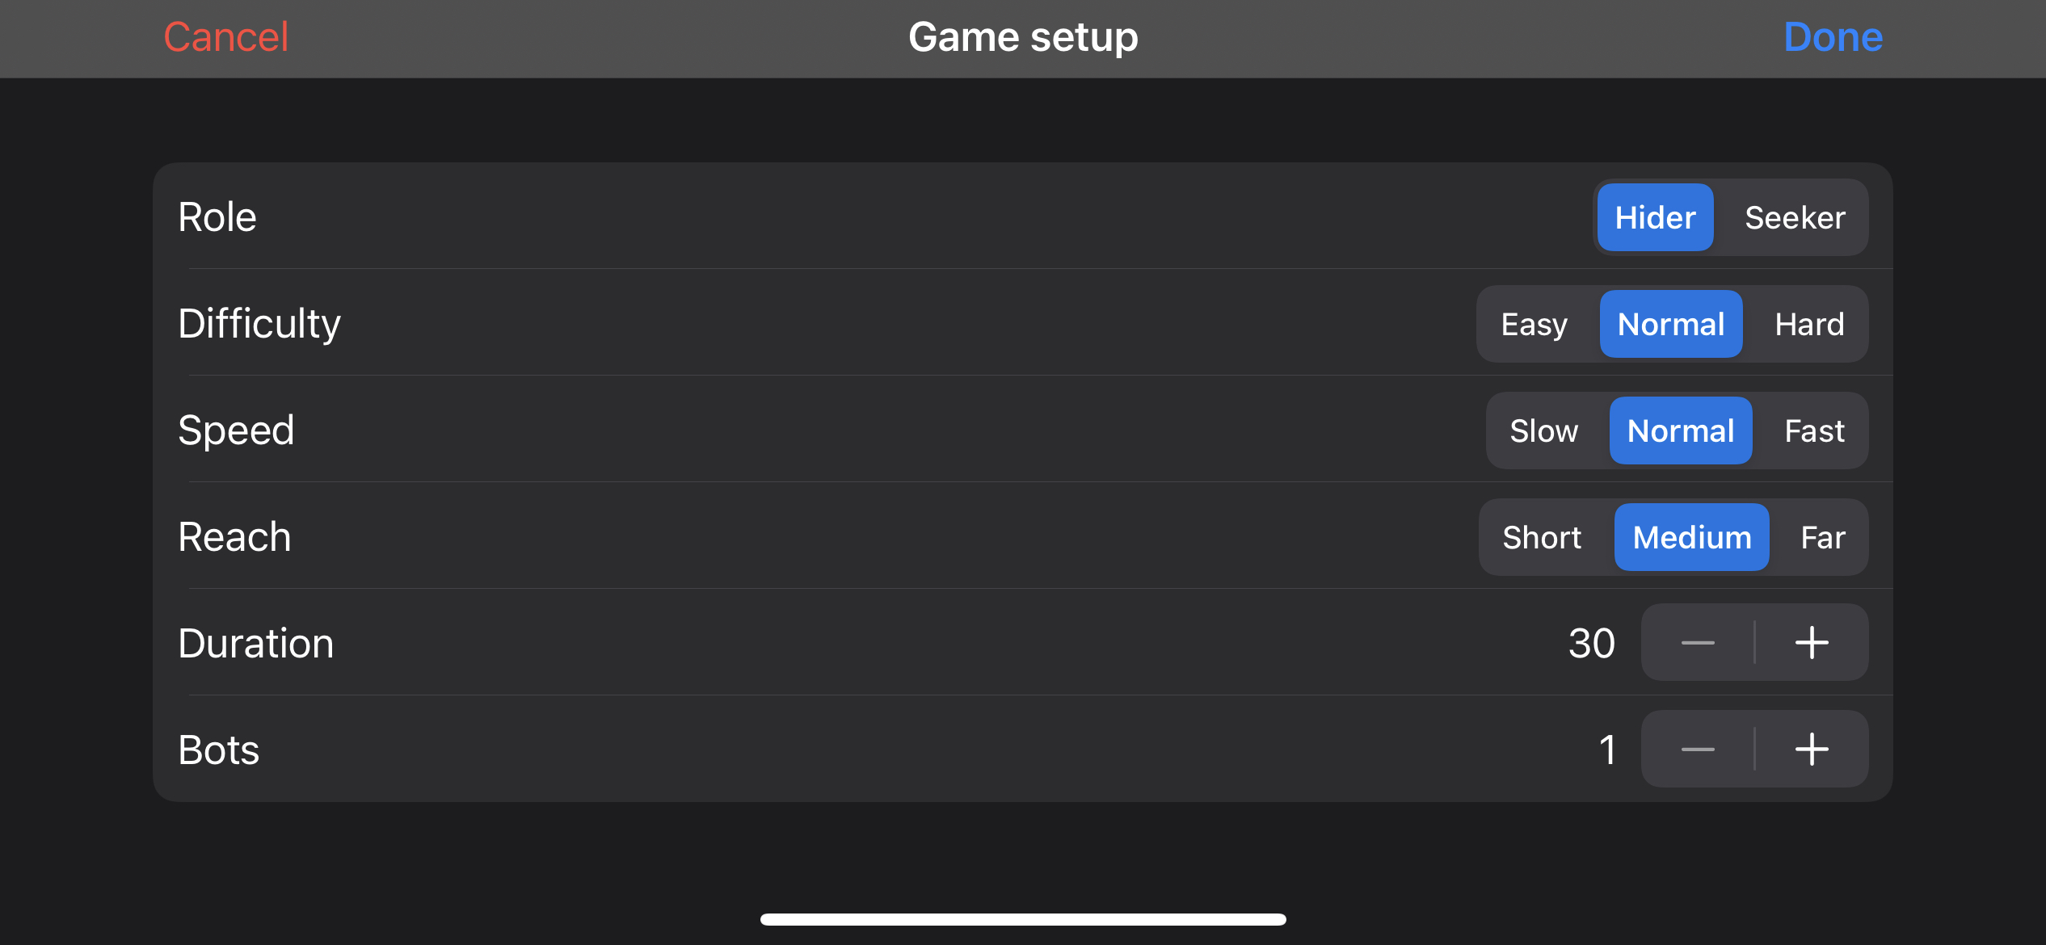

This scene is where the user will customise the game to their preferences. The player will be able to set all of this to what they want, but the duration and bots options are limited to 5 minutes and 5 bots.

#### Game scene

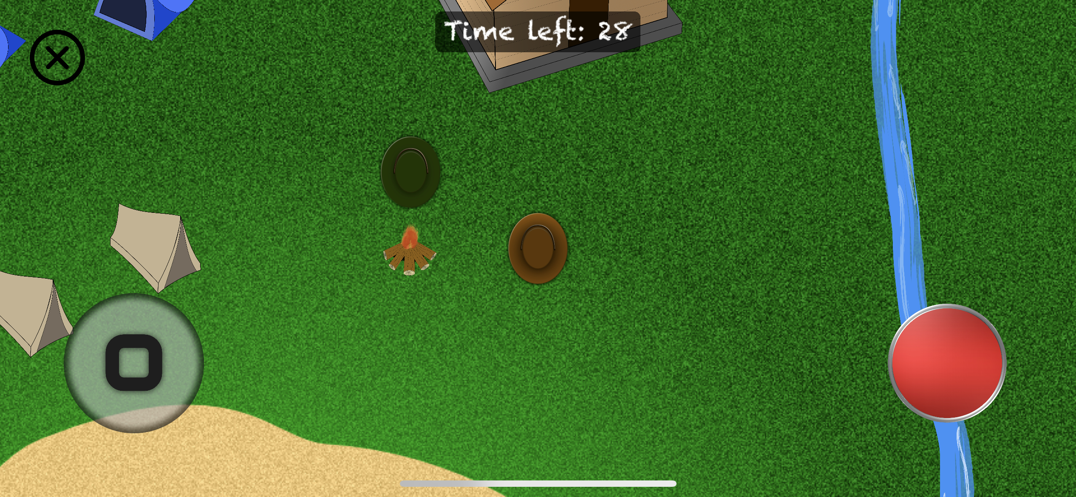

This is the game scene. This scene contains some static UI (The joystick to the left of the screen and the button to the right of the screen). The player is in the centre of the screen as a brown hat. You can see some tents and a house where the hiders can hide. The green hat on the screen is the seeker, and in this case, it’s played by a bot. The player has a set reach and if the players reach intersect with another node it will reveal a label under the button on the right stating the action available. At the top of the screen there is a timer counting down how much time you have until the game is finished.

### Start screen assets

#### Play button

|  |  |
| --- | --- |
|  | This is a button for the main menu, It’s. a plank with the written option on it. |

#### Help button

|  |  |  |
| --- | --- | --- |
|  | This is a button for the main menu, It’s. a plank with the written option on it. |  |

#### Stick

|  |  |
| --- | --- |
|  | This is a stick for the main menu. I will have the other main menu option on it as a sign with different labels on it. |

#### Start screen

|  |  |
| --- | --- |
|  | This is the background image the start will have. This is a snapshot of the game in action and supposed to show what can happen. |

### Game scene assets

#### Campfire

|  |  |
| --- | --- |
|  | This is a simple campfire created by me. |

#### Mountain

|  |  |
| --- | --- |
|  | This is a mountain created for the left side of the map. |

#### Game background

|  |  |
| --- | --- |
|  | This is the background image for the game scene. |

#### River

|  |  |
| --- | --- |
|  | This is a simple river to cut off the map. |

#### Hider

|  |  |
| --- | --- |
|  | This is the image a player with the role of a hider will have. It’s supposed to look like a hat from top down. |

#### Seeker

|  |  |
| --- | --- |
|  | This is the image a player with the role of a seeker will have. It’s supposed to look like a hat from top down. |

#### Tent new

|  |  |
| --- | --- |
|  | This is a tent where a player can hide. |

#### Tent old

|  |  |
| --- | --- |
|  | This is a tent where a player can hide. |

#### House

|  |  |
| --- | --- |
|  | This is a house where multiple people can hide. |

### User interface

#### Button

|  |  |
| --- | --- |
|  | This is a generic button. I found it on <https://pixabay.com/illustrations/generic-button-button-3d-sign-1357003/> under the license of **Pixabay License (**[**https://pixabay.com/service/license/**](https://pixabay.com/service/license/)**)** |

#### Joystick background

|  |  |
| --- | --- |
|  | This is a plain background I created for the joysticks. |

#### Joystick node

|  |  |
| --- | --- |
|  | This is the joystick itself. |

## User Interface Design

# Implementation

# Testing

## Overall Approach to Testing

## Automated Testing

### Unit Tests

### User Interface Testing

### Stress Testing

### Other Types of Testing

## Integration Testing

## User Testing

# Critical Evaluation

# Annotated Bibliography

|  |  |
| --- | --- |
| [1] | Apple Inc, “Responding to Frame-Cycle Events,” 2021. [Online]. Available: https://developer.apple.com/documentation/spritekit/skscene/responding_to_frame-cycle_events. [Accessed 24 04 2021].  I have used apple's photo what happens in each frame when using SpriteKit |

# Appendices

## Review of similar games

### Hide ‘N Seek!

This is a free and popular online game, and it has an average rating of 4.7 and is number 37 in Action. This game takes place in a maze where the hiders need to outlast the seeker and the other hiders.

|  |  |
| --- | --- |
| Positive | Negative |
| The game is fun and addictive, and people can be freed by other players when they have been captured. | The game has too many ads and they aren’t age appropriate for a 4+ game. The game is a lot of data tracking and most of the data collected is linked to you. |

<https://apps.apple.com/gb/app/hide-n-seek/id1491654968>

### Hide‘N Find

This is a free offline game with an average rating of 3.3. The game takes place in a box where are some walls to hide behind.

|  |  |
| --- | --- |
| Positive | Negative |
| The game isn’t tracking any data nor linking any date to you. | The game has a hyper focused seeker that only targets you, and the seeker can reach through walls to catch you. |

<https://apps.apple.com/gb/app/hiden-find/id1509189851>

### Hide & Seek Fun Game

This is a free offline game with an average rating of 3.7. The game takes place in a jungle with a pyramided in the centre of the map.

|  |  |
| --- | --- |
| Positive | Negative |
| This game gives you some customisability in the form of changing controls, changing outfit and game difficulty. | The game has a hyper focused seeker that only targets you. You have no indication of who the seeker is. It has a messy user interface, and the game has too many ads. |

<https://apps.apple.com/gb/app/hide-seek-fun-game/id1495168019>

### Hide and Seek..!

This is a free offline game with an average rating of 2.5. The game takes place at a house where the hiders are invisible and you as the seek have to find them.

|  |  |
| --- | --- |
| Positive | Negative |
| The game looks very nice and has a good user interface. The game has also included physics in the game with object falling when moving too close. | The game forces you to be the seeker, and the controls are very sensitive. The field of view is very small which makes it very hard to actually find someone. |

<https://apps.apple.com/gb/app/hide-and-seek/id1537051480>

* 1. Third-Party Code and Libraries
  2. Ethics Submission

Image not found or type unknown

11/03/2021

For your information, please find below a copy of your recently completed online ethics assessment

Next steps

Please refer to the email accompanying this attachment for details on the correct ethical approval route for this project. You should also review the content below for any ethical issues which have been flagged for your attention

Staff research - if you have completed this assessment for a grant application, you are not required to obtain approval until you have received confirmation that the grant has been awarded.

Please remember that collection must not commence until approval has been confirmed.

In case of any further queries, please visit [www.aber.ac.uk/ethics](https://www.aber.ac.uk/ethics) or contact ethics@aber.ac.uk quoting reference number 19208.

**Assesment Details**

AU Status

Undergraduate or PG Taught

Your aber.ac.uk email address pev2@aber.ac.uk

Full Name

Petter Vang Brakalsvalet

Please enter the name of the person responsible for reviewing your assessment.

Neil Taylor

Please enter the aber.ac.uk email address of the person responsible for reviewing your assessment nst@aber.ac.uk

Supervisor or Institute Director of Research Department

cs

Module code (Only enter if you have been asked to do so) CS39440

Proposed Study Title

2D game construction in Swift

Proposed Start Date 25 January 2021

Proposed Completion Date 1 June 2021

Are you conducting a quantitative or qualitative research project? Mixed Methods

Does your research require external ethical approval under the Health Research Authority? No

Does your research involve animals? No

Does your research involve human participants? Yes

Are you completing this form for your own research? Yes

Does your research involve human participants? Yes

Institute

IMPACS

Please provide a brief summary of your project (150 word max)

My aim is to create a hide and seek style 2D game for iOS. This game will take place at night in a forest. The players will have multiple places to hide. However, some of the hiding places will have some form of punishment depending on how good of a hiding spot it is. For example, if a player hides in a tent the player would rustle the tent and make a noise, or if they are hiding in a tree they will get tired and eventually fall down. When a player takes the role of a seeker, they will have the option to use a flashlight to extend their field of view, and if another player is within reach the seeker can catch them. When a player is caught they will be frozen in place until another player frees them or the game finishes. When the game finishes they will be greeted with a new page where they will be able to see who was caught and who wasn’t. I might ask other people to test my game and to provide some feedback.

I can confirm that the study does not involve vulnerable participants including participants under the age of 18, those with learning/communication or associated difficulties or those that are otherwise unable to provide informed consent? Yes

I can confirm that the participants will not be asked to take part in the study without their consent or knowledge at the time and participants will be fully informed of the purpose of the research (including what data will be gathered and how it shall be used during and after the study). Participants will also be given time to consider whether they wish to take part in the study and be given the right to withdraw at any given time. Yes

I can confirm that there is no risk that the nature of the research topic might lead to disclosures from the participant concerning their own involvement in illegal activities or other activities that represent a risk to themselves or others (e.g. sexual activity, drug use or professional misconduct). Yes

I can confirm that the study will not induce stress, anxiety, lead to humiliation or cause harm or any other negative consequences beyond the risks encountered in the participant’s day-to-day lives. Yes

Please include any further relevant information for this section here:

Where appropriate, do you have consent for the publication, reproduction or use of any unpublished material? Not applicable

Will appropriate measures be put in place for the secure and confidential storage of data? Yes

Does the research pose more than minimal and predictable risk to the researcher? No

Will you be travelling, as a foreign national, in to any areas that the UK Foreign and Commonwealth Office advise against travel to? No

Please include any further relevant information for this section here:

Is your research study related to COVID-19? No

If you are to be working alone with vulnerable people or children, you may need a DBS (CRB) check. Tick to confirm that you will ensure you comply with this requirement should you identify that you require one. Yes

Declaration: Please tick to confirm that you have completed this form to the best of your knowledge and that you will inform your department should the proposal significantly change. Yes

Please include any further relevant information for this section here:

* 1. Code Samples